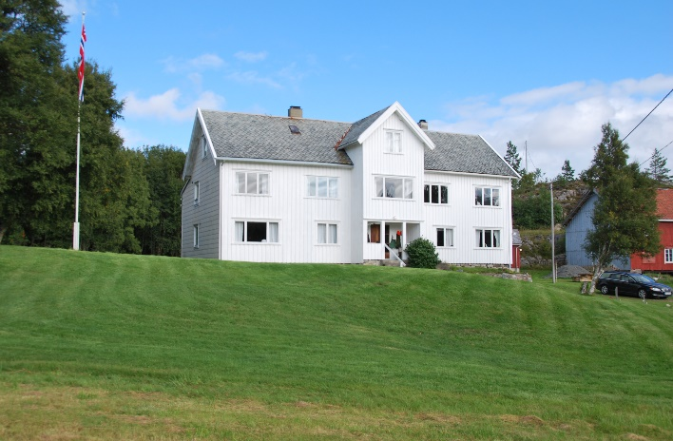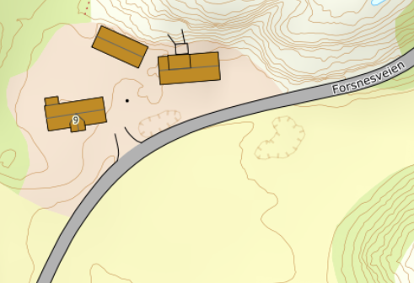

DIRECTIONS

HOUSE 203
After the Hitra tunnel follow the road 714 to Fillan. After about 2.5 km turn left onto road 713 towards Forsnes/Kvenvær. Follow the road for about 37 km and then turn left onto Forsnesveien. Follow Forsnesveien for about 350m. Your holiday home is on the right-hand side of the road. At the house you will find a sign with the Hitra Turistservice logo and the house number.
Key: You will receive the keys from the landlord
Landlord: Torstein Grindstad
Mobil phone: 004792847105
Address: Forsnesveien 9
7246 Sandstad

