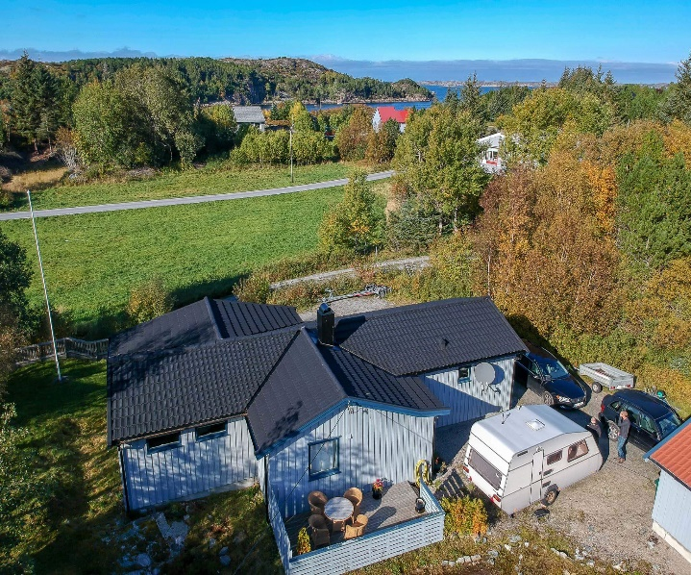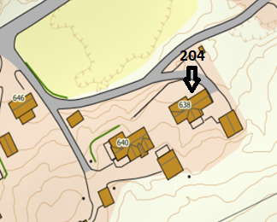

DIRECTIONS

HOUSE 204
After the Hitra tunnel follow the road 714 to Fillan (approx. 15 km). After passing Fillan follow on the same road towards Frøya. After about 6 km turn left in a right bend onto road 713 towards Kvenvær. Follow the road for approx. 28 km until you find a sign with the Hitra Turistservice logo and the house number on the left-hand side of the road in Kvenvær. Turn left here and after about 50m turn left again. Drive to the end of the street. Your holiday home is there.

Keys: You will receive the keys from the landlord
Landlord: Knut Ellefsen
Mobile phone.: 004792612920
Address: Vesthitterveien 638
7243 Kvenvær

