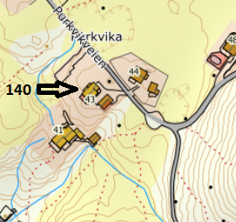

DIRECTIONS

HOUSE 140, MAUSUNDVÆR
After the Hitra tunnel follow the road 714 to Fillan (approx. 15 km). After passing Fillan follow the road 714 towards Frøya. After passing through the Frøya tunnel, take the first exit at the roundabout towards Sistranda. Drive about 10.5 km further on road 714, then turn onto road 716 towards Dyrøy/Nordskag. Drive about 1 km and turn right towards Dyrøy. Follow the road in the direction of Dyrøy for about 8 km to the grocery store ("Coop prix"). From there the ferry to Mausund goes. Follow the road Fv436 on Mausund for approx. 1.4 km. Your holiday home is on the right-hand side. At the house you will find a sign with the Hitra Turistservice logo and the house number.

Keys: You will receive the keys from the landlord
Landlord: Kent Haraldsen
Mobile phone: 004748043366
Address: Purkveien 43
7284 Mausund

