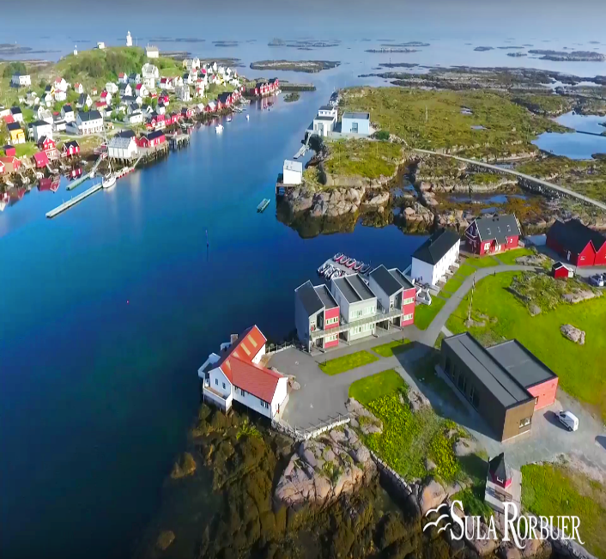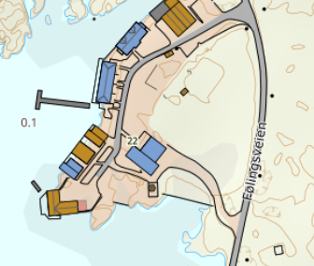

DIRECTIONS

SULA RORBUER

After the Hitra tunnel follow the road 714 to Fillan (approx. 15 km). After passing Fillan follow the road 714 towards Frøya. After passing through the Frøya tunnel, take the first exit at the roundabout towards Sistranda. Drive about 10.5 km further on road 714, then turn onto road 716 towards Dyrøy/Nordskag. Drive about 1 km and turn right towards Dyrøy. Follow the road towards Dyrøy for about 8 km to the grocery store (“Coop prix”). From there the ferry goes to Sula. Follow the road Fv437 on Sula for approx. 2.2 km. Then turn right and follow the road for approx. 200m. Here you will find Sula Rorbuer
Keys: You will receive the keys from the service person.
Service person: Roger Larsen
Mobile phone: 004793825218
Address: Føllingsveien 22
7280 Sula

