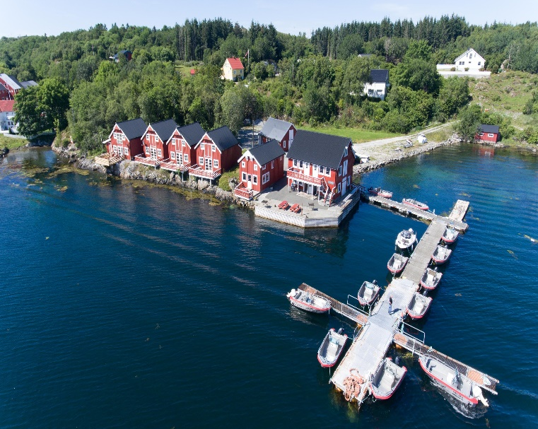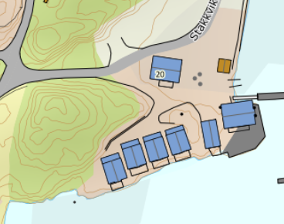

DIRECTIONS
STADSVIK BRYGGER
HOUSE 216-220C
After the Hitra tunnel follow the road 714 to Fillan (approx. 15km). After passing Fillan follow the road 714 towards Frøya. About 15 km after Fillan, you cross a bridge. After the bridge, turn left towards Kjerringvåg and drive about 1.3 km until you see a bus stop with the Hitra Turistserivce logo on the left. Turn right here onto the dirt road. Drive this dirt road about 500mtr. until you see the holiday home complex on the left-hand side. There is also a sign with the house numbers.
Keys: You will receive the keys from the landlord
Landlord: Halvar Stadsvik
Mobile phone: 004791174121
Address: Stakkvikveien 20
7252 Dolmøy

