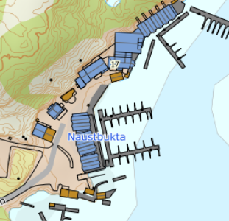

DIRECTIONS

Angelamfi Grefsnesvågen

After the Hitra tunnel follow the road 714 to Fillan (15km). After passing Fillan follot the road 14 towards Frøya. After about 6 km turn left in a right bend onto road 713 towards Kvenvær. Follow the road for about 23 km until you reach Grefsnesvågen. Turn right here onto Grefsnesvågenveien and follow the road for about 500m until you reach Angelamfi. On the right you will find the reception of the complex.
Keys: You will receive the front door key and boat instruction upon arrival
Landlord: Jan Stene
Service person: Nijole
Mobil phone.: 004745961171
Address: Grefsnesvågenveien 17
7243 Kvenvær

