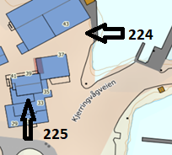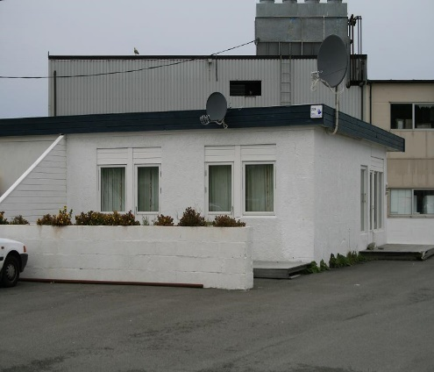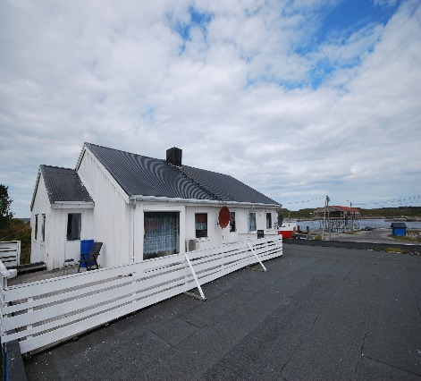

DIRECTIONS

HOUSE 224 + 225
After the Hitra tunnel follow the road 714 to Fillan (approx. 15km). After passing Fillan follow the road 714 towards Frøya. About 15 km after Fillan, you cross a bridge. After the bridge, turn left towards Kjerringvåg and drive about 2.7 km. Turn right here in the direction of Dolm/Havn and drive to the supermarket right at the port. Your holiday home 224 is next to the supermarket. The 225 is on the back of the supermarket. Here you will also see a sign with the Hitra Turistservice logo.
Keys: You will receive the keys from the landlord
Key box code: 2240
Code for WIFI: fjordlyeie
Landlord: Stian Thorvaldsen
Mobile phone: 004792666704
Address: Kjerringvågveien 33
7252 Dolmøy

