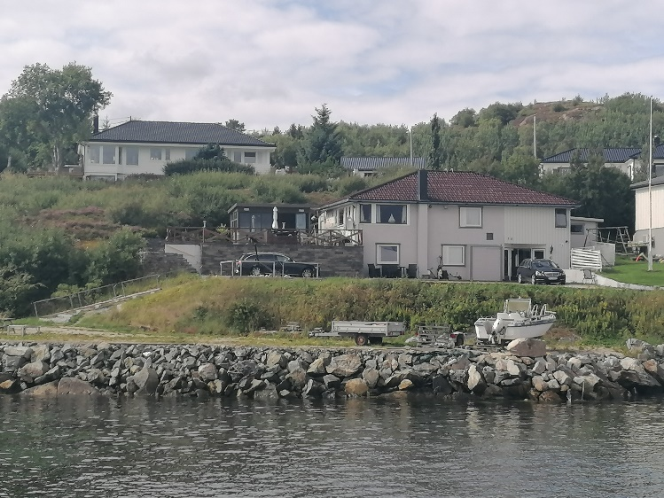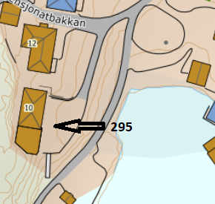

DIRECTIONS

HOUSE 295

After the Hitra tunnel, follow the road 714 to Fillan (approx. 15km). After passing Fillan follow the road 714 towards Frøya. About 1 km after Fillan, turn right towards Fjellverøya/Ansnes and drive about 6 km to the Ansnes sign. Turn right there and follow Ansnesveien. After 200m turn left onto Nessabakkan. After about 100m turn right onto Pensjonatbakkan. Here you can see the sign with the Hitra Turistservice logo and the house number.
Keys: You will receive the keys from the landlord.
Landlord: Hjalmar Grøntvedt
Mobile phone: 004795522799
Address: Pensjonatbakkan 10
7241 Ansnes

