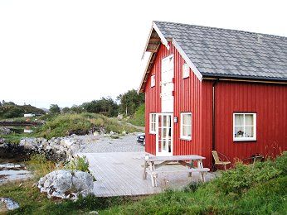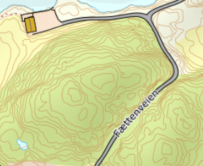

DIRECTIONS

HOUSE 240
After the Hitra tunnel follow the road 714 to Fillan (approx. 15 km). After passing Fillan follow the road 714 towards Frøya. About 1 km after Fillan turn right towards Fjellverøya/Ansnes. After about 6.5 km you will reach the bridge to Fjellverøya. Drive over both bridges and turn right at the next crossing towards Akset/Mastad. From here, continue straight ahead for about 4.5 km - until you see a sign with "FÆTTEN" and the Hitra Turistservice logo on the right. Turn right here and follow the small path to your holiday home. (approx. 800 m)
Keys: You will receive the keys from the landlord.
Landlord: Geir Sæther
Mobile phone: 004795928067
Adress: Fættenveien 39
7242 Knarrlagsund

