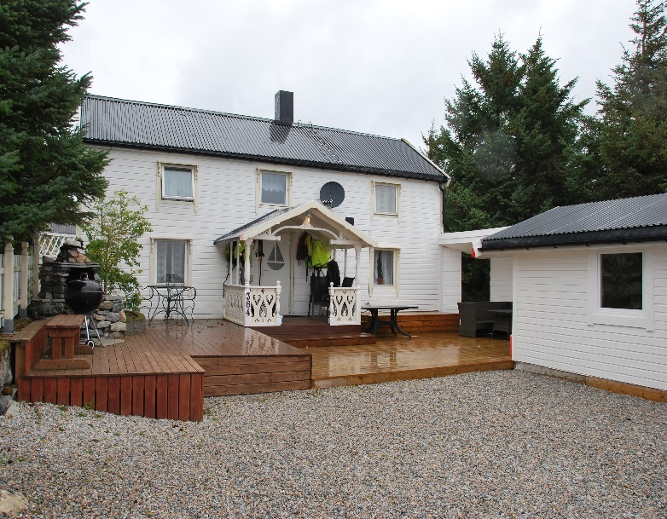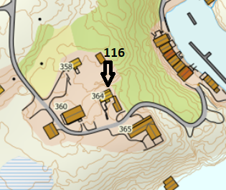

DIRECTIONS

HOUSE 116
After the Hitra tunnel follow the road 714 to Fillan (approx. 15 km). After passing Fillan follow the road 714 towards Frøya. After passing through the tunnel, take the second exit at the roundabout towards Titran. After 21 km you will find a sign "Bua" on the right side. Turn right here onto the gravel road and follow the road to the end (approx. 3.5 km). Your holiday home is on the right-hand side. At the house you will find a sign with the Hitra Turistservice logo and the house number.

Keys: You will receive the keys from the landlord
Landlord: Johan Solstad
Mobile phone: 004741449861
Address: Buaveien 364
7266 Kverva

