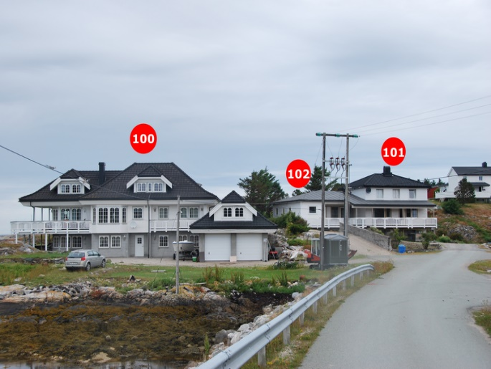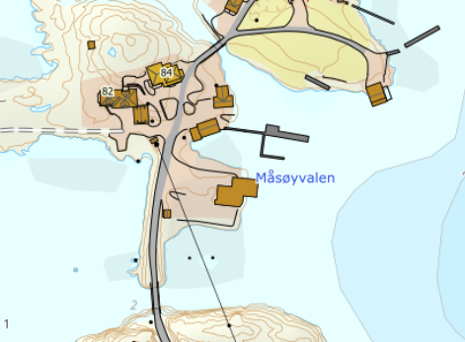

DIRECTIONS

HOUSE 100A & 100B
After the Hitra tunnel follow the road 714 to Fillan (approx. 15 km). After passing Fillan follow the road 714 towards Frøya. After passing through the tunnel, take the second exit at the roundabout towards Titran/Nordskaget. After 18.4 km you will find a sign "Måsøvalen" on the right-hand side. Turn right here and follow the road for about 800m. Your holiday home is on the left-hand side. At the house you will find a sign with the Hitra Turistservice logo and the house number.
Keys: You will receive the keys from the landlord
Landlord: Ole Kristian Måsøval
Mobile phone: 0047-47173741
Address: Måsøvalveien 82
7266 Kvera

