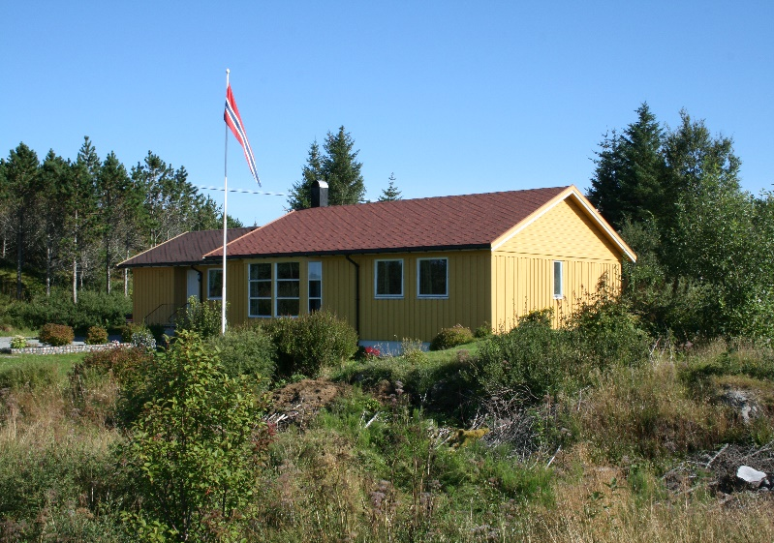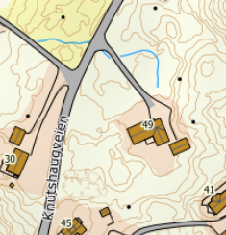

DIRECTIONS

HOUSE 215

After the Hitra tunnel follow the road 714 to Fillan (approx. 15 km). After passing Fillan follow the road 714 towards Frøya. About 15 km after Fillan, you cross a bridge. Turn left here towards Knutshaug. After about 200m turn right towards Knutshaug. Then it's another 1.5 km on a small road until you reach Knutshaug. Keep driving until you see the sign with the Hitra Turistservice logo and the house number 215 on the right-hand side. The big yellow house is your holiday home.

Keys: You will receive the keys from the landlord
Landlord: Tore Kvalvik
Mobile Phone: 004791711804
Address: Knutshaugveien 49
7252 Dolmøy

