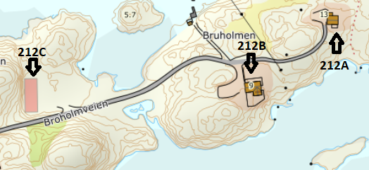

DIRECTIONS

HOUSE 212A+212B+212C
After the Hitra tunnel follow the road 714 to Fillan (approx. 15km). After passing Fillan follow the road 714 towards Frøya. About 15 km after Fillan, you cross a bridge and turn left towards Kjerringvåg. From here it is another 1.5 km until you see the house sign with the Hitra Turistservice logo and the house number 212 on the right-hand side at the bus stop. Turn right here onto Broholmveien and drive the small road about 400 mtr. Along this road are the 3 cottages, 212C comes first, 212B in the middle and 212A at the end.

Keys: You will receive the keys from the landlord
Landlord: Stian Thorvaldsen
Mobile phone: 004792666704
Address: Broholmveien 13
7252 Dolmøy

